April 29, 2024

The software alchemists

gray masud joel

ENter Act system design  
Document

DRAFT

Table of Contents

Introduction 2

Design level Class Diagram 2

Sequence Diagram 3

State-Chart Diagram 3

# **Introduction**

This system design document outlines the architecture and functionality of Enteract, detailing the core components including design-level class diagrams with attributes, methods, and pseudocode, state chart diagrams illustrating object states, and sequence diagrams demonstrating the flow of interactions for each use case. Enteract aims to redefine the landscape of digital content interaction, fostering meaningful connections and driving unprecedented value for both creators and consumers alike.

# **Design level Class Diagram**

<https://github.com/Masud181100/Group-Project/tree/main>

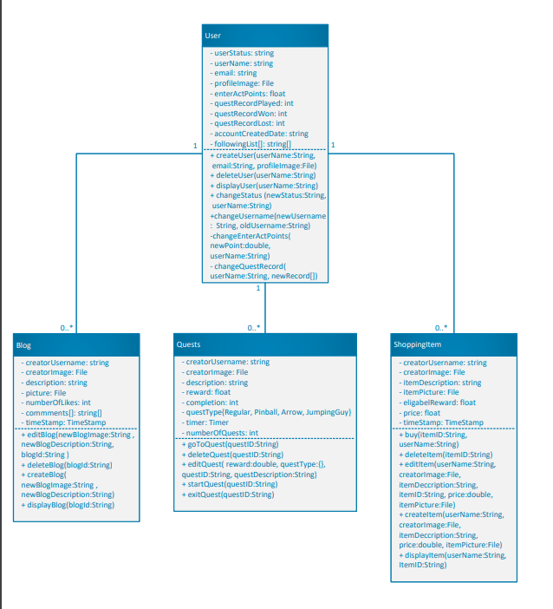

# **Sequence Diagram**

# <https://github.com/Masud181100/Group-Project/tree/main>

# **State-Chart Diagram**

# <https://github.com/Masud181100/Group-Project/tree/main>